**Prelab-Week-7**

**Prelab Questions:**

1. What is Purging rule?
2. Write the cost function to find shortest path from source to destination in Multi-stage graph by using backward approach
3. Find the shortest path from source to destination by using forward approach for the graph given below

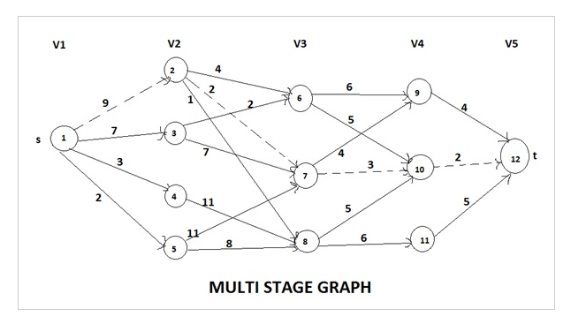

1. Find the solution for the following 0/1 knapsack instance

n = 4, w = 5 kg, (w1, w2, w3, w4) = (2, 3, 4, 5), (b1, b2, b3, b4) = (3, 4, 5, 6)

**Pre-lab programs:**

1. Implement 0/1 Knapsack algorithm.
2. Implement Multi-Stage graph with backward approach
3. Implement Multi-Stage graph with forward approach

**Lab Program:**

Alice and Bob take turns playing a game, with Alice starting first.

Initially, there is a number n on the chalkboard. On each player's turn, that player makes a move consisting of:

* Choosing any x with 0 < x < n and n % x == 0.
* Replacing the number n on the chalkboard with n - x.

Also, if a player cannot make a move, they lose the game.

Return true *if and only if Alice wins the game, assuming both players play optimally*.

**Example 1:**

**Input:** n = 2

**Output:** true

**Explanation:** Alice chooses 1, and Bob has no more moves.

.